Business Process Flow
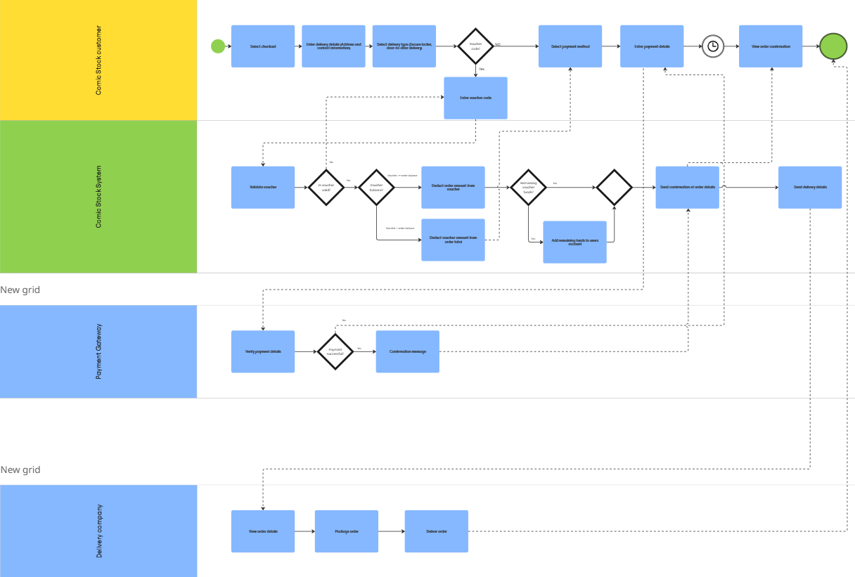
Access on Miro here

